PROPOSAL FOR
<Project / Client Name>

Presented To:

Presented By:

ABC Restrictions

This data shall not be disclosed and shall not be duplicated, used, or disclosed in whole or in part for any purpose. If a contract is awarded to this provider as a result of or in connection with the submission of this data, the client or prospective client shall have the right to duplicate, use, or disclose this data to the extent provided in the contract. This restriction does not limit the client’s or prospective client’s right to use the information contained in the data if it is obtained from another source without restriction. The data, subject to this restriction, is contained in all marked sheets.

Table of Contents
1. Introduction 4
2. Functional Requirements & Scope 5
3. Solution Architecture & Highlights 6
4. Project Approach 7
4.1 Project Strategy 7
4.2 Engagement and delivery Organization 8
5. Project Resource, Schedule & Milestone 9
5.1 Resource Allocation 9
5.2 Schedule & Milestone 9
6. Cost Estimate 10
7. Assumptions 11
8. Reference 12

1. Introduction

Established in 2011, ABC is a leading provider of technology-based business solutions that leverage a globally positioned workforce of over 2000 software engineers and subject matter experts. From locations throughout the US, India, Asia Pacific, and Europe, ABC custom develops and supports a broad range of industry specific enterprise business applications through a proven delivery model that combines US based consulting and delivery centers with highly scalable and cost-effective offshore development and testing facilities. ABC has a long standing history of approaching every client and every project as a partner, carefully configuring teams of business and technology professionals that will complement and optimize client-side project groups, while guaranteeing the highest quality deliverable in the shortest time-to-market achievable.

ABC’s effectively managed intellectual capital is the foundation from which our clients draw upon specialized knowledge in an increasingly broad range of business applications and computing environments. The loyal following of clients seeking to leverage our proven delivery methodology includes many small and midsized companies, as well as many respected leaders in Pharmaceuticals, Finance & Banking, Insurance, Life Sciences, Telecommunications, Marketing, Retail, Transportation & Logistics, and Consumer Electronics.

ABC compliments its vast array of human and technological resources with strategic partner relationships including proven solution providers and market leaders in Business Intelligence, CRM, Web-To-Print, Wireless Communications, Mobility, Field Force Automation, and Managed Services.

At the core of ABC’s value proposition is our ability to assemble and dedicate a solution delivery team by any means necessary to meet our clients’ unique requirements. Strict adherence to ISO and CMMI certified standards and processes applies to every client and every project regardless of the approach that best meets the clients’ needs: Onsite, Offsite, Offshore, or our award winning Hybrid Onshore/Offshore project engagement model.

2. Functional Requirements & Scope

[Specify the high level requirements and scope of work to be done and the proposal is submitted for. Though lot of items for this section will come from client’s request, don’t just copy from what client has given]

3. Solution Architecture & Highlights

[This section is optional. If required State the highlights of the proposed architecture or solution with the diagram]

4. Project Approach

4.1 Project Strategy

ABC understands the significance of developing application that involves active participation of the business owners during the requirements and user interface design phases of the project life cycle. To support such active participation and collaboration, this project will engage an onsite and offsite project team model to support the project requirements effectively. ABC recommends the following project execution strategy.

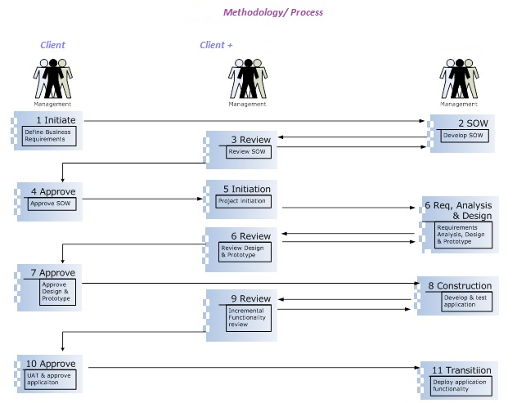

4.2 Engagement and delivery Organization

[This diagram and the text below needs to be verified with the Project organization proposed. This structure may change from client to client depending on the offerings]

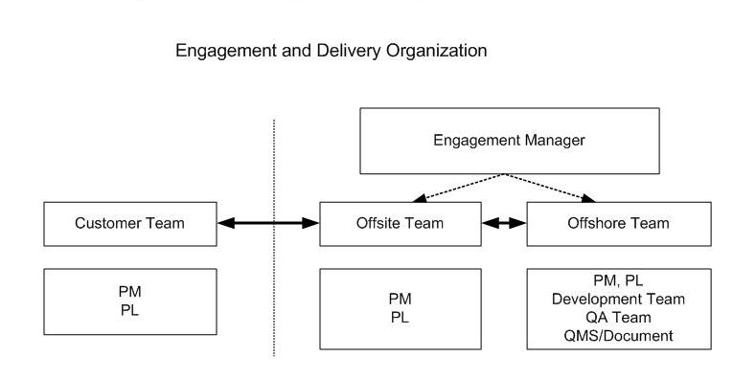
[
- ABC project team comprises of the professionals that will be split between US operations and development center in India.
- The core US based project team comprises of Engagement Manager, Project Manager, Lead Technical Architect and Creative Director.
- The offshore development team comprises of Project Manager, Lead Technical Architect, Presentation Layer developers, Business Layer developers, Database layer developers, Quality Assurance, Infrastructure support personnel.
- The US based project team will be client facing and will be managing the communications and work schedules of the development team in India.
- ABC execution of the projects enables for a seamless progression of the schedules tasks without the need for client to directly interact with development team offshore.
- ABC has adapted this model for a number of projects and has developed efficient processes and methodologies to ensure quality deliverables.
- Periodic status meetings and access to the development environment are provided to the client project team to ensure the progress of the project deliverables. ]

5. Project Resource, Schedule & Milestone

5.1 Resource Allocation
[This section may be optional, depending on the client’s interest. Specify the Resources allocated for the execution of the project. Break it down between onsite and offshore.
For fixed price projects don’t provide the costs of the resources]

5.2 Schedule & Milestone
[Provide a tentative schedule. This may change in the SOW]

# | Phases | Deliverables | Exit Criteria | Start Date | Complete Date
1 | Project Initiation | SOW & Project Plan | Approved SOW and Project Plan
2 | Requirements | Requirement | Approved Requirement
3 | Design | Prototype | Approved Prototype
3 | Design | Functional Spec | Approved Functional Spec
4 | Development | Unit tested Application | Reviewed Source code
5 | QA Certification | Integration, Functional and Acceptance Test Plans | Integration, Functional and Acceptance Test Results
6 | Training & Deployment | Fully tested Application | Go Live

6. Cost Estimate

[For fixed price project, just provide final costs or costs at the module level for bigger projects. Add a disclaimer stating that this might be subject to change in the SOW]

7. Assumptions

[Specify the Assumptions which are assumed in developing this proposal and to execute this project]

8. Reference

[Specify ABC experience related to this project of similar size, functionality and/or technology used. This section is purely optional unless client insists on this or if it is really needed to bid]

